Intro to Deep Learning

Assignment 3

1. I used dictionaries to store the values obtained from forward propagation and back propagation, to avoid the use of multiple variables at each step. The results obtained by training the model for 500 iterations, along with the test set accuracy is shown below:

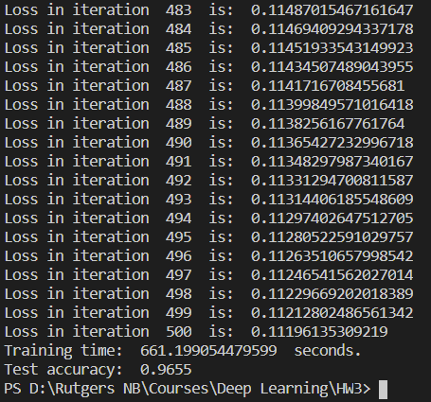

1. Utilizing PyTorch, the model was trained for 10 epochs, with the average training loss for each epoch shown in the image below. Additionally, the training set time, average loss for the test set and test set accuracy is shown in the screenshot below:

